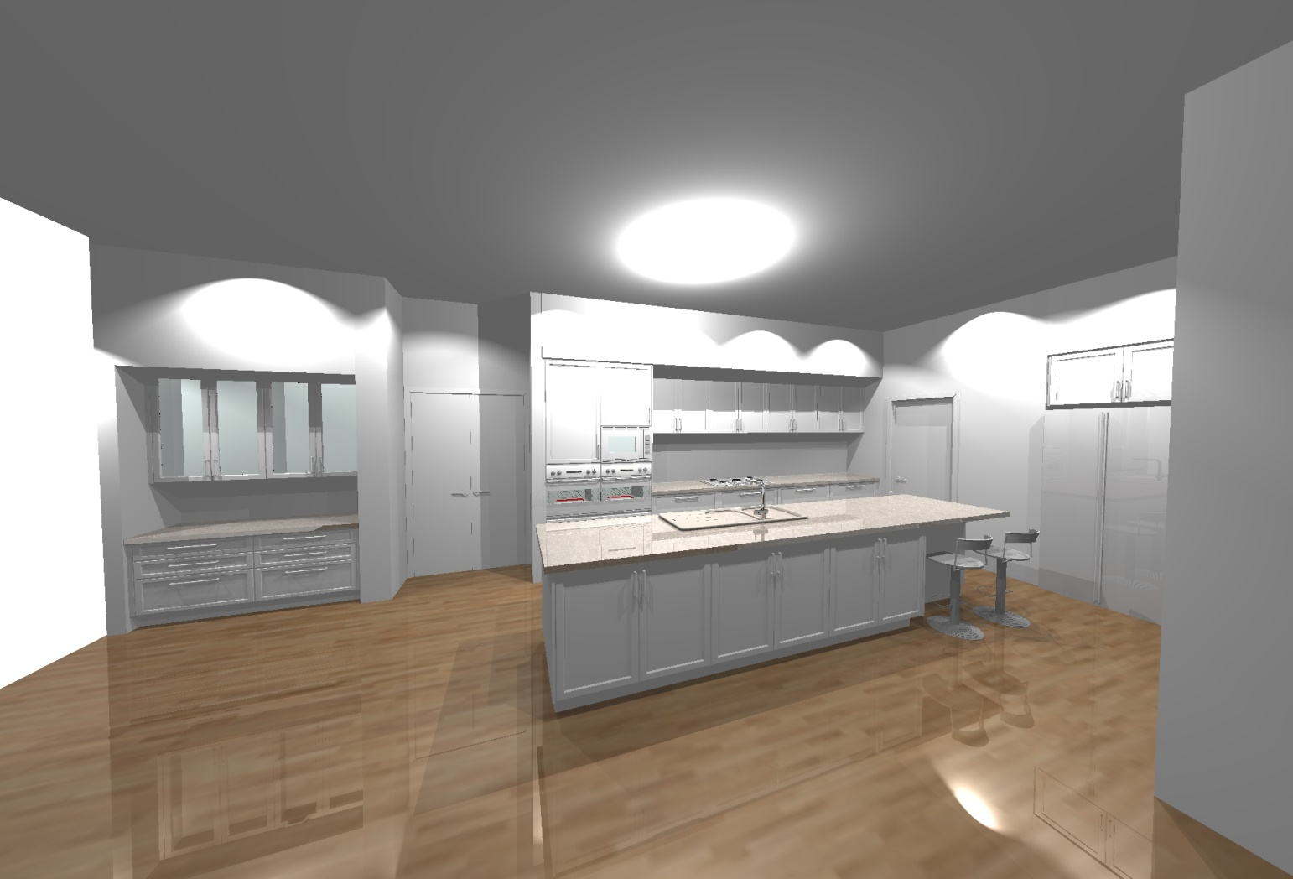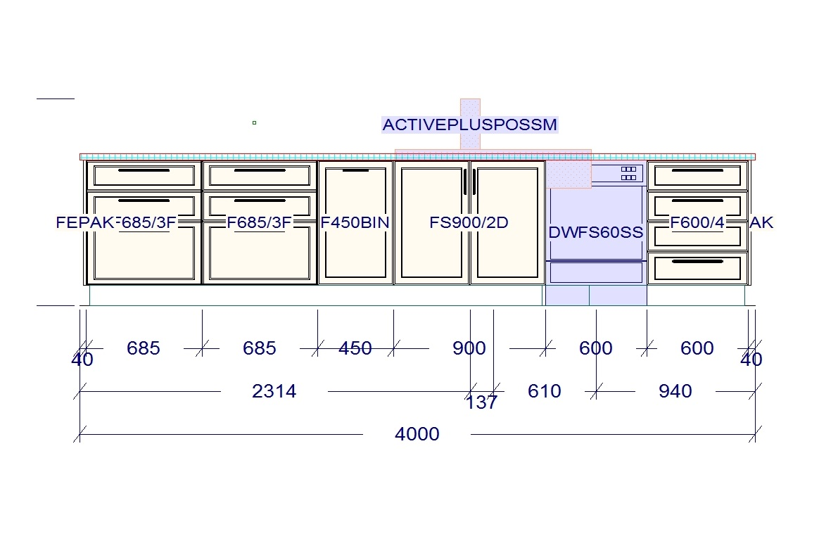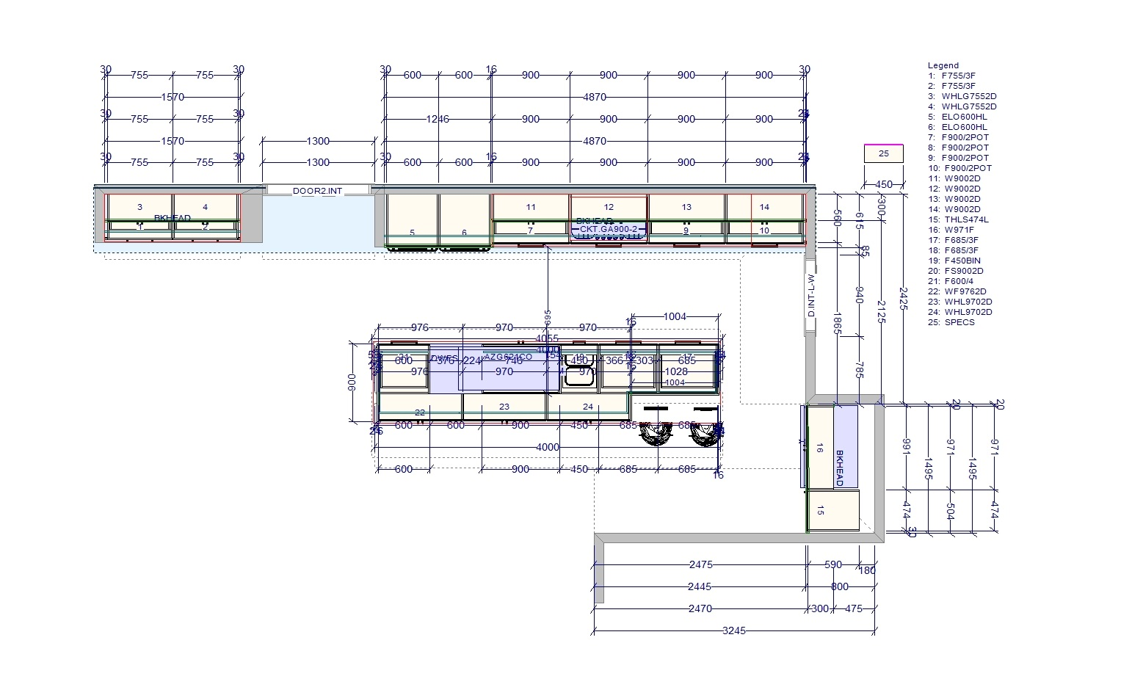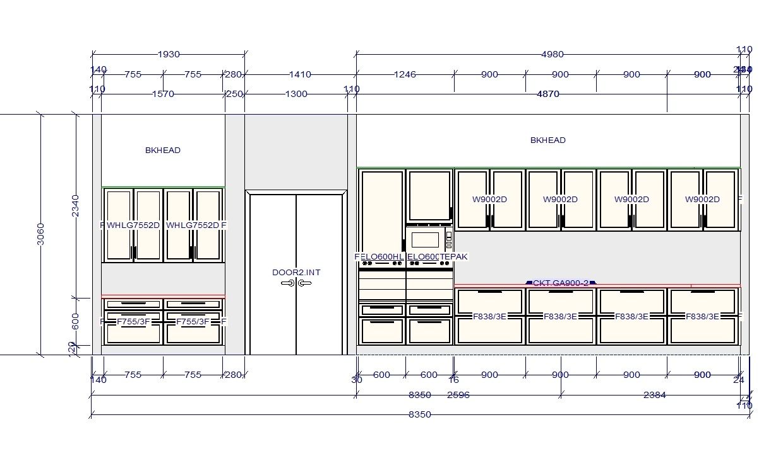

**Prindeville, Alan & Sue  
24 Northampton Drive, Midland, WA 6056**



Plans, Elevations and Renders are NOT presented as accurate depictions but are an approximation of the final installed product.

This Plan, Elevation and Renders are copyright and may not be distributed without prior, written agreement and payment of the appropriate fees.

Render

Elevation

Elevation

Plan