Steven J. Brems
Naples, FL 34113
sjbrems@aol.com

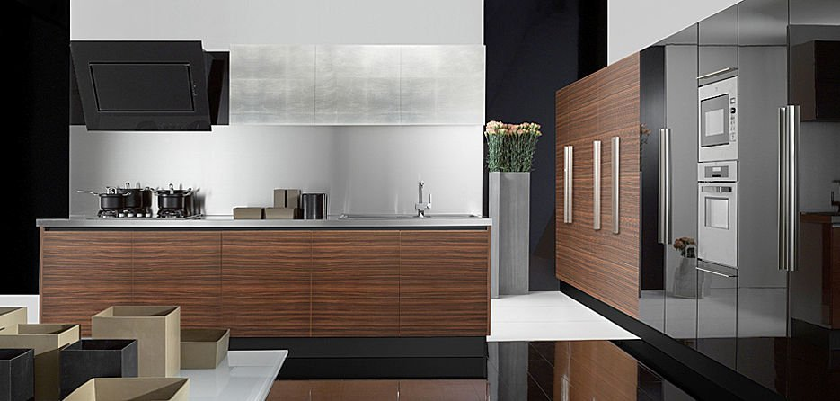

Floorplans, Elevations, Kitchens, Baths, Closets,
Entertainment Centers & Home Offices
Any scale: Imperial or Metric

Hourly or contract pricing

For a personal presentation, please call (239) 272-8908

